Leila Holen
Retail Management

Store Layout Assignment

Our assignment this week is to research and evaluate the use of floor plans in a business setting. I read an article that first you must utilize the correct type of floor plan in your business in order to better serve your customers. Its efficiency will encourage product discovery and create a wonderful experience.

The clothing store I chose is in Valley View Mall and caters to women. One reason I like it is that when you walk by, you are able to glance in and see if there are new arrivals or what is on sale. While not a straight floor plan that allows ease of movement around the displays, the angular floor plan allows an invitation to explore and find something that may not have been on the shopping list.
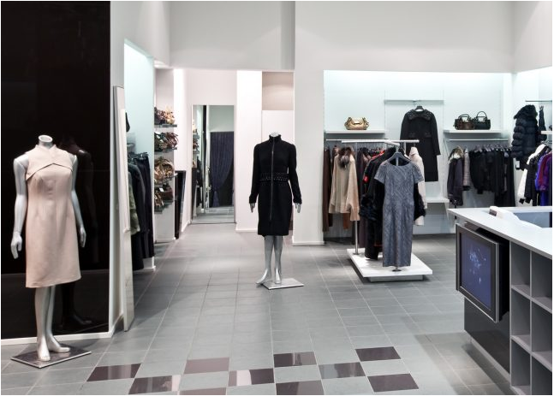
To the left and behind the mannequin, dressing rooms exist and on the opposite side is a reflection of this section, in reverse. Clothing is located on the outside walls with displays in the center and in the back area. The front window is utilized as a display area and can offer viewing of racks or mannequins.

Signage in the store indicates “Clearance” and “Nightwear”. The signage can be moved as needed and the check-out counter is in the back of the store. There is a sign on the jewelry but is not part of the actual stand or wall. I feel that is a good retail idea, as a person may walk by a display and decide that since they are in the store and they see something, why not purchase it while in the store already.

Space management is very equal and visually appealing. When the current fad is unveiled, it seems that has the prime spot and the previous fad is still in front of the store, but may be placed on a rolling rack or a section back.

The atmosphere is very uplifting and pleasant. The lighting gives it an uplifting, pleasant and welcoming atmosphere and the windows across the front of the store is very pleasant. The sales associates are pleasant and there is always laughter somewhere in the store when you go in.

I happen to like the store layout as you are able to walk around from one side to the other in a circle and see everything there is. At times, in the evening when I shop, there are sometimes racks moved around and I like that nothing is permanent except the center walls and the outer walls. I have spoken to one employee and she assured me that the displays are updated once a week and while they may not move far, the associates are always aware of where the items have been placed. Since it is a major retailer, the store floor plans may be the same and instructions of where to place items may be on purpose from the marketing department.

In the article “Store Floor Plans 101” by Francesca Nicasio, https://www.vendhq.com/blog/retail-store-floor-plan/, it was interesting that even how the racks should be placed for effective showing. The article was very informative and I made me more aware of when I shop now. The influences are important and while I may not like a particular idea, they are in place for a reason.

